Route 53

It’s a DNS resolution concept which will resolve DNS name with Ip
Moto –
Assign a custom domain name for a public server’s public ip by using ROUTE 53.
And try to access the webserver using that custom domain .
Use Simple routing policy
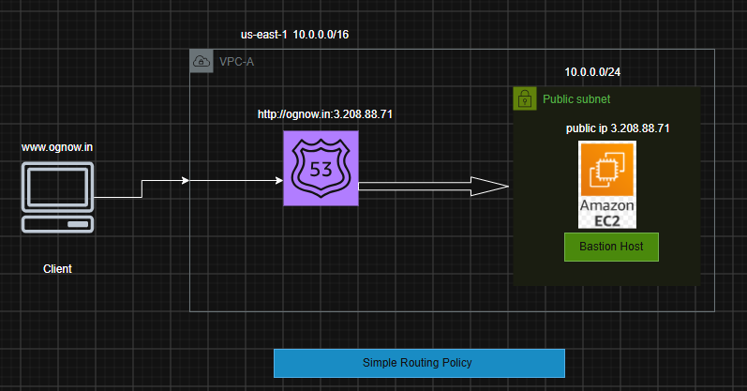

Prerequisite:-
- VPC
- Public Subnet
- Public EC2 instance where application should be running (nginx)
- Route 53
- A Custom Domain.
Steps -:
- First create a vpc and inside it create a public subnet
- Inside the public subnet create a Bastion host and install ngnix server .
- Replace the index.html page with your custom website index source code . (/usr/share/nginx/html/index.html).

- Then configure Route 53 for the custom domain (ognow.in) by using the Simple Routing Policy.
- Register domain (ognow.in)
- Hosted Zones
a. public –it is for internet/internet facing /public hosting i.e when the domain is allowed for public access
b. private- it is for internel network/private hosting i.e when the domain is allowed for internal private team access
- Records
- Route 53 policies
- Now try accessing the webservice using custom domain ie www.ognow.in .

Implementation:-

1. First create a vpc and inside it create a public subnet

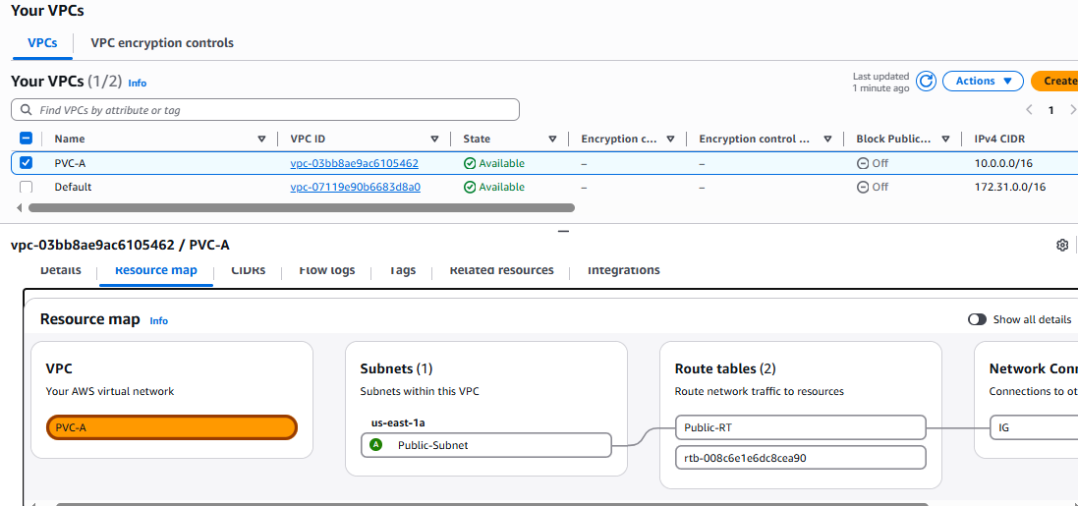

2. Inside the public subnet create a Bastion host and install ngnix server
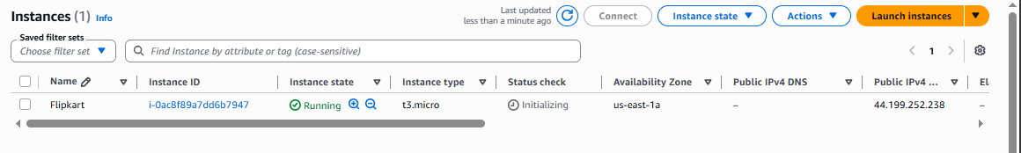

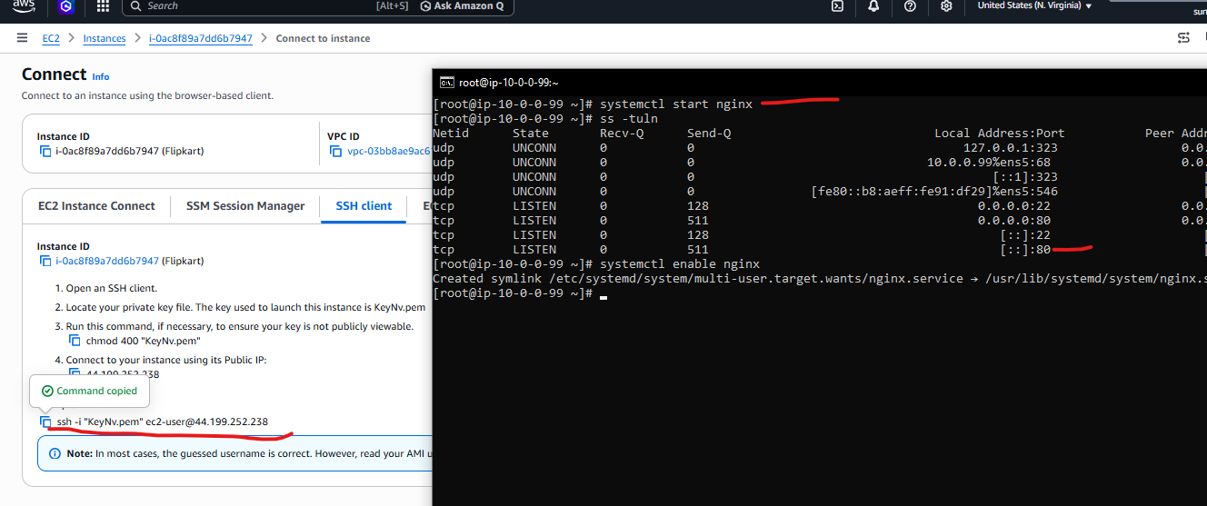
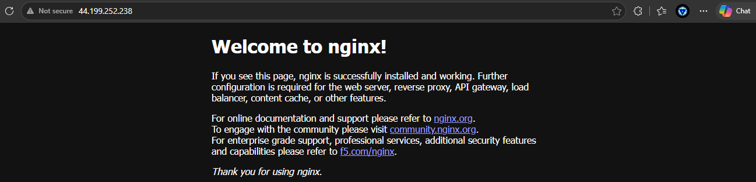

3.Replace the index.html page with your custom website index source code . and try accessing using the public ip for testing.
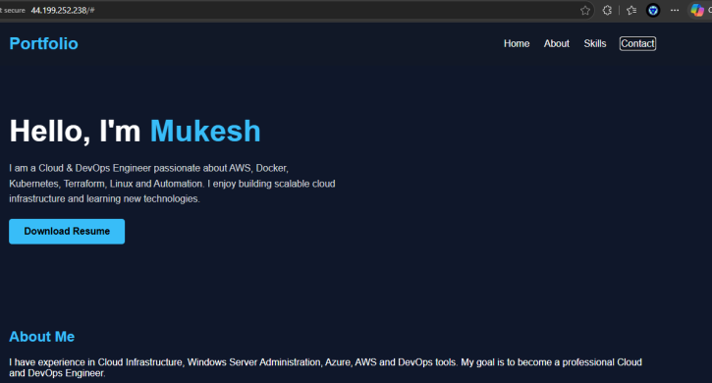

4. Then configure Route 53 for the custom domain (ognow.in) by using the Simple Routing Policy.
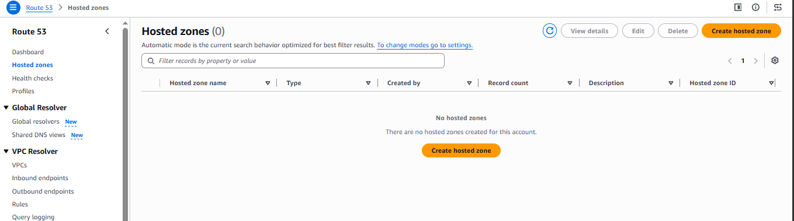

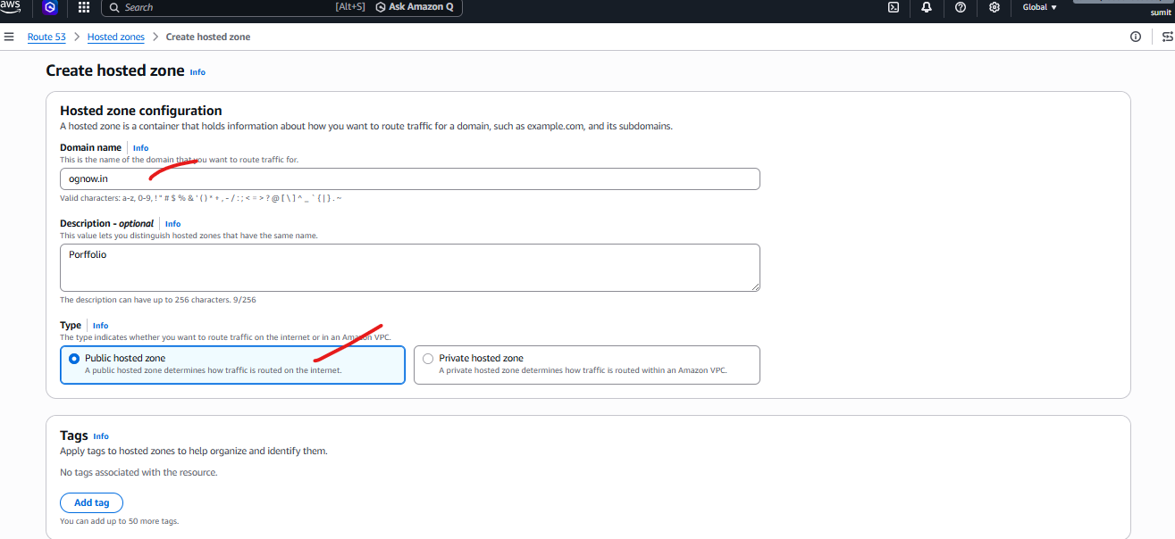
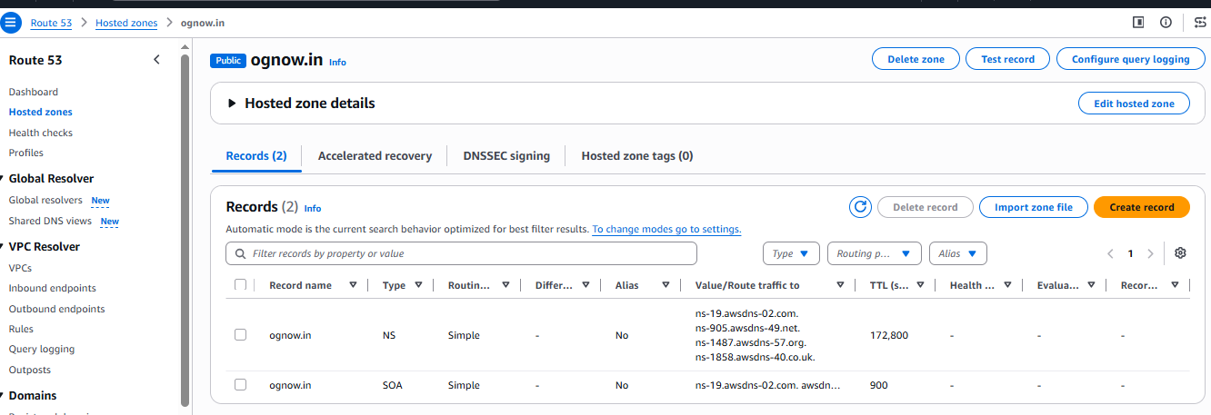

NS –Name system Record for Authentication purpose
SOA – Adminstration purpose

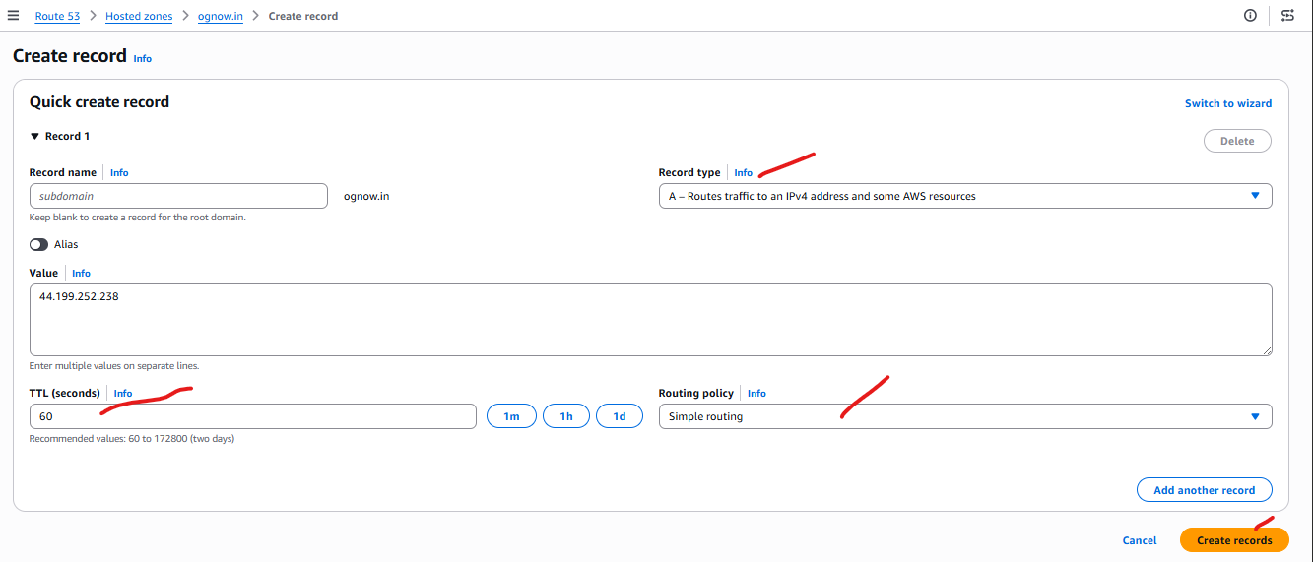
Record Type – in which way domain will resolve ip
Value – Server’s Public /Elastic IP ( Elastic Ip recommended).
TLL – how much time it will take to reflect
Routing Policy – how the domain will redirect traffic

Now you will able to access the website using http://ognow.in .

